11 Chemistry - Organic –Geometrical Isomerism

Name: ____________________ Date: ________________

Name the following structures using IUPAC nomenclature.

1.
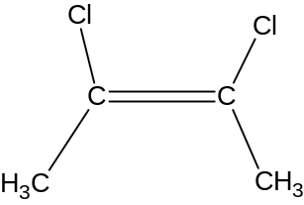 ____________________________

2.
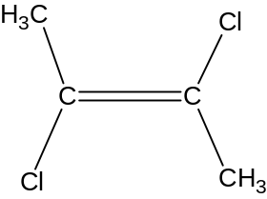 _____________________________

3.
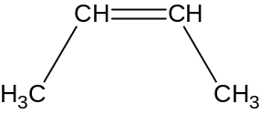 ______________________________

4.
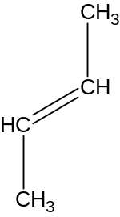 ______________________________

5.
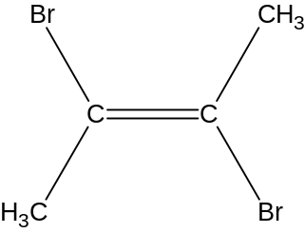 _______________________________

6.
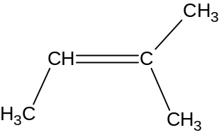
________________________________

7.

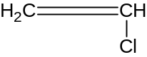 _________________________________

8.

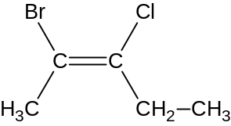 _________________________________

9.

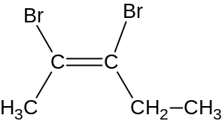 _________________________________

10.

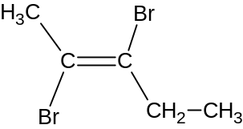 __________________________________
11 Chemistry - Organic –Geometrical Isomerism ANSWERS

- cis-2,3-dichloro-2-butene
- trans-2,3-dichloro-2-butene
- cis-2-butene
- trans-2-butene
- trans-2,3-dibromo-2-butene
- 2-methyl-2-butene
- 1-chloroethene
- ?
- cis-2,3-dibromo-2-pentene
- trans-2,3-dibromo-2-pentene

